**DESIGN DOC FOR Match-3 System**

* *This type of hacking mini game system is a clone of Pipe Mania.*
* *The player will chose the level in the Menu Screen where:   
  Easy – The player have move moves.*

*Medium – The number of moves is a bit more that the number of pipes.*

*Hard –The number of moves is 30.*

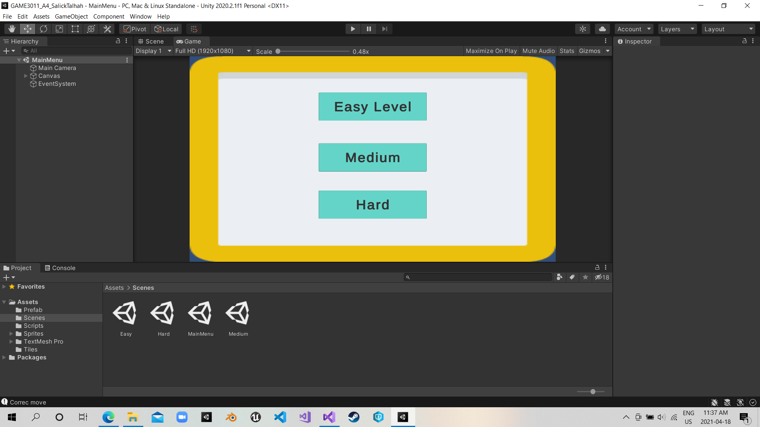

* 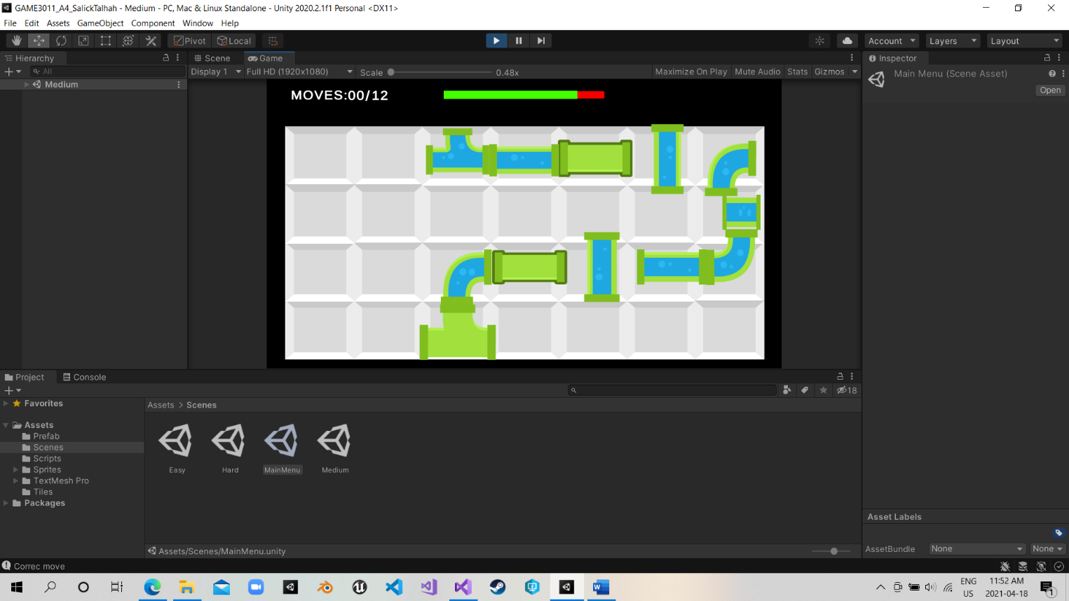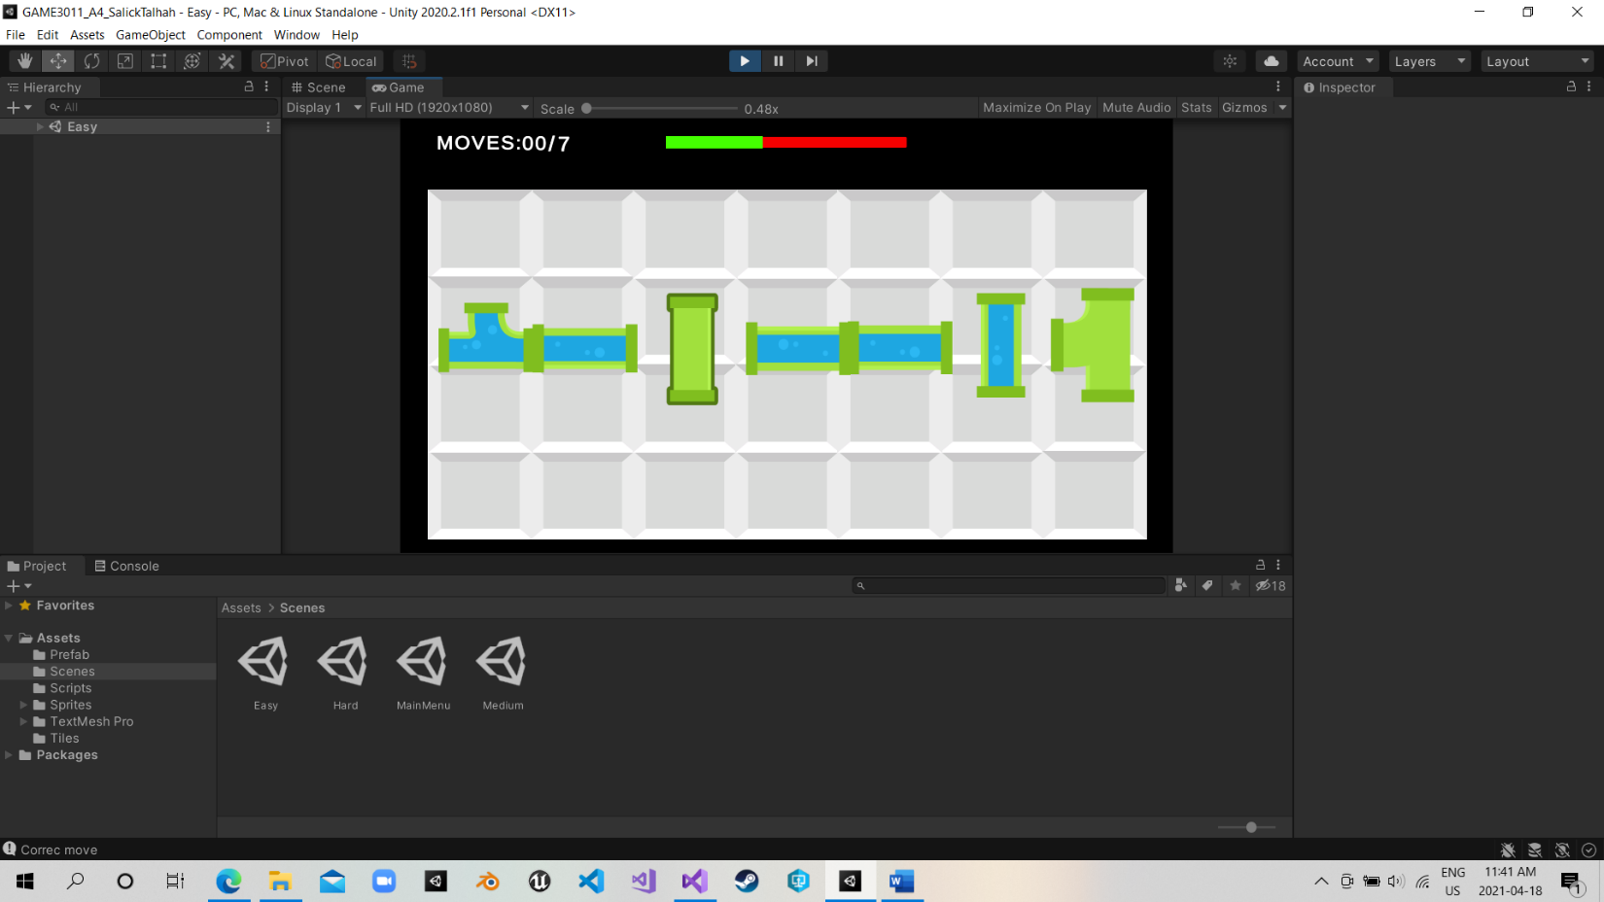*The player use the left click to select one item and change it’s rotation.*

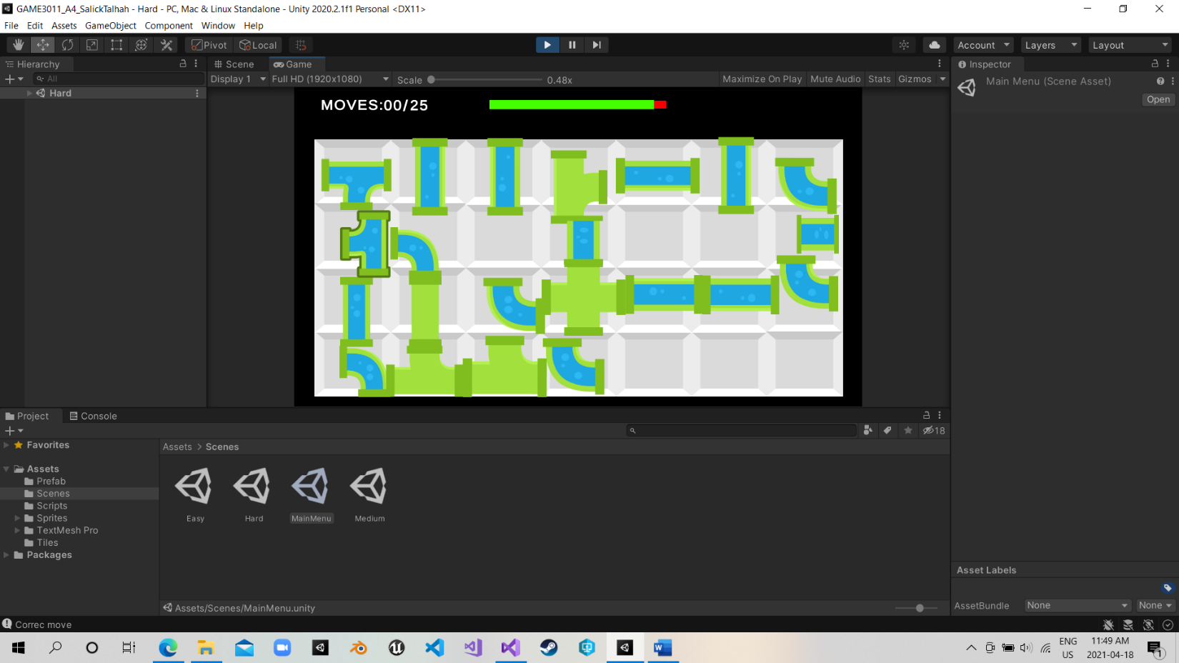

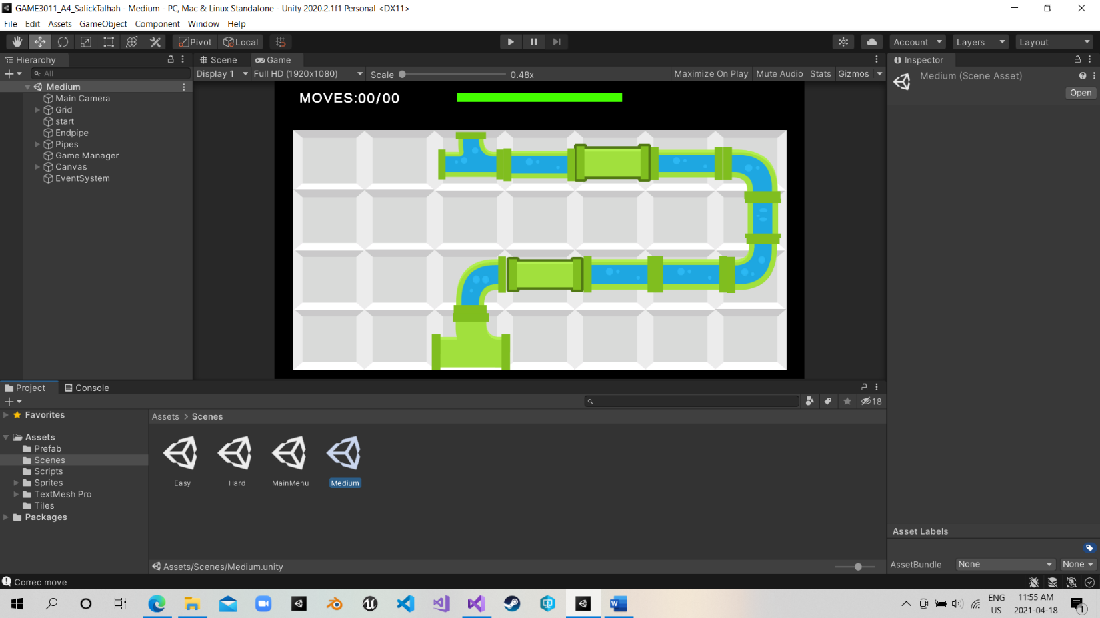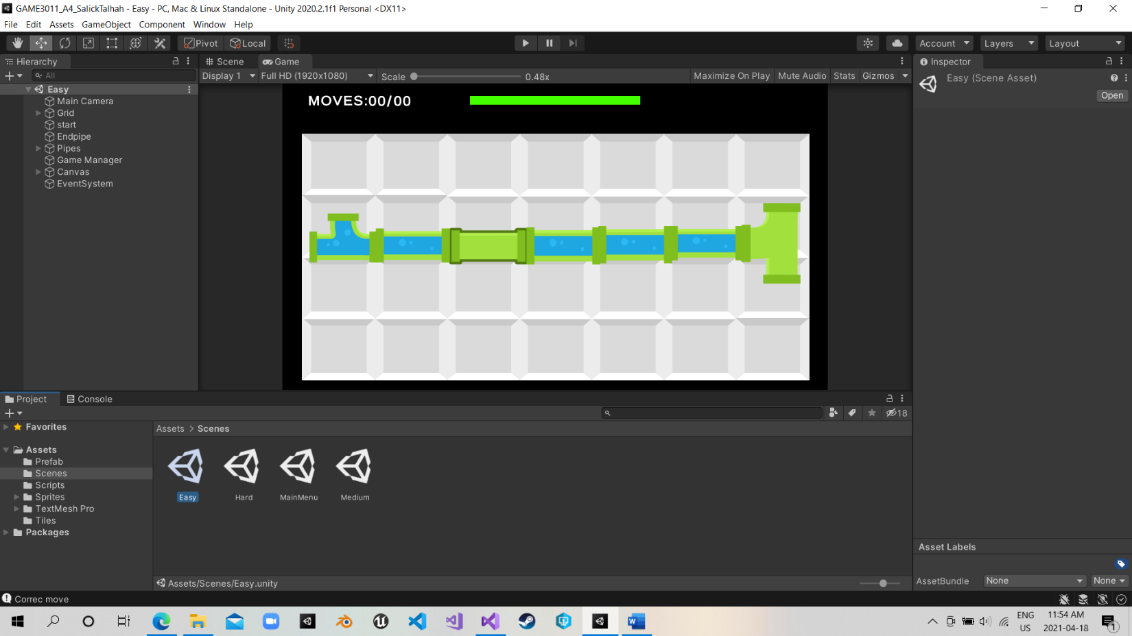**Correct:**

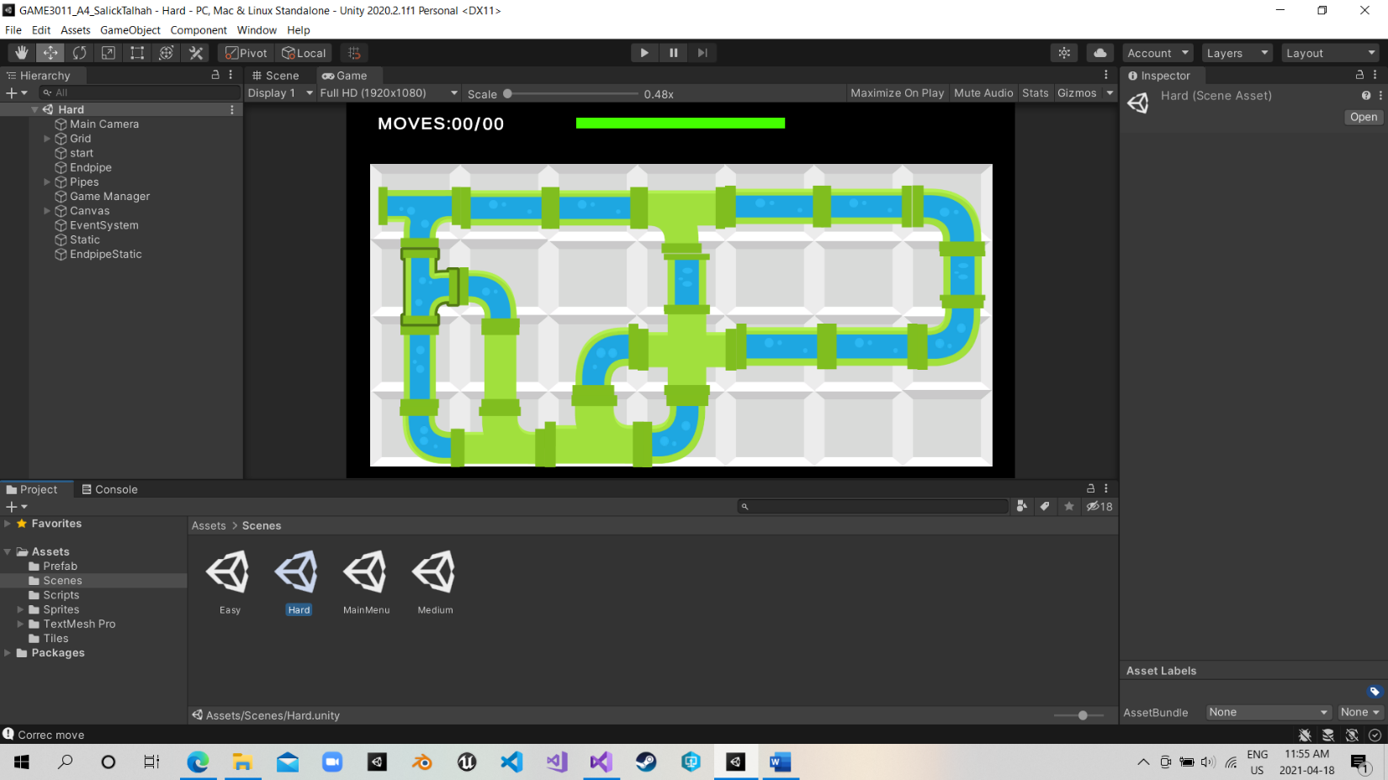

**UI**

* *In the top left, this is the move counter. Once it is equal to the number od use you have, the game is over.*
* *The Bar on the top is the Timer, the time varies between level, easy = 15, medium 20, hard = 25.*

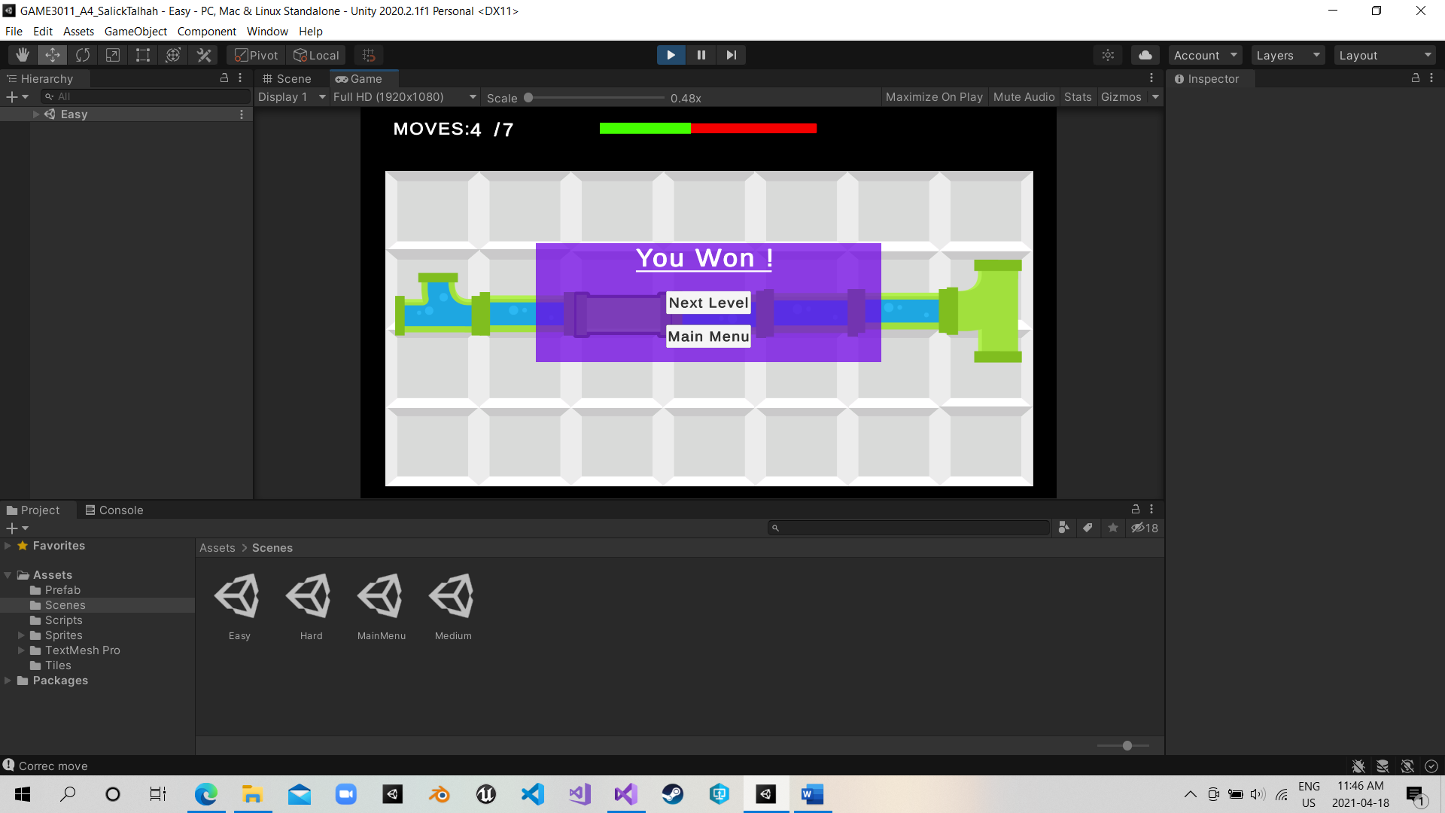**Game over & win Screen.**

